# Game Diary

Let’s start with my big mistake. I misunderstood the assignment and thought I had to play 3 different games for 10 hours and thus I played World of Warcraft(Blizzard 2004), Hunt: Showdown(Crytek 2009) and Genshin Impact(miHoYo 2021) for a total of 10 hours. About 4 hours each. But only one day before the deadline I heard that you should play one game for 10 hours. Thus for this diary I will be talking about World of Warcraft(WoW) as I played this for well over 10 hours in the last couple weeks.

## What is World of Warcraft?

Wow is a massively multiplayer online role-playing game released in 2004. It has gone through many patches and expansions over the years. It a game were you can do anything really. People play it for Player vs Player, Player vs Environment, roleplay, collecting, pet battles, community, making money(in game and out of game), etc.

## Dated entries

9/11 until 22/11 each day for at least a couple hours. On the 19th of November I focused for about an hour on going through the blizzard store. On the 20th of November I focused for about 5 hours on playing a fresh account to experience the new player experience. I wanted to see what type of microtransactions a new player sees in the first 20 levels of the game.

## My background

My background with WoW is quiet extensive. I have been playing the game on and off since 2005. I have been part of the same guild since 2017 and been an officer since 2018. I have been part of all forms of content expect for Player vs Player and Roleplay. So these two things won’t be talked about in my diary.

## Available micro transactions

World of Warcraft has 5 type of microtransactions availed in the in-game store.

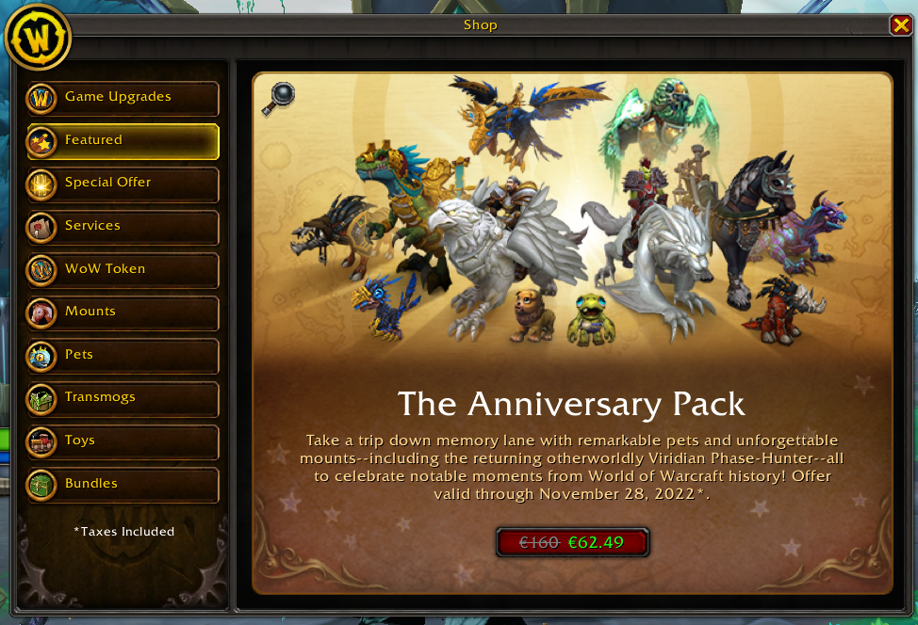

Figure 1 World of Warcraft in game Store screenshot made on 22/11/2022 [1]

### Game time

To play WoW you need to pay about 12 euros per month. It’s a bit less or more depending on deals. This has always been the case since the beginning of the game.

### Game Upgrades

You can upgrade your game to the newest version. This comes down to you spending 50 euros every two years to buy the new version. This isn’t really a microtransaction since its 50 euros. However you can upgrade it to more expensive packs after buying the game to gain skins for 20 euros.

### Transmogs/Toys/Mounts

There are a couple different transmogs(skins) available in the store. Toys are items that do little playful things in the game that have no effect in any meaningful way. Mounts are well mounts. They look cool and make you move faster.

### Services

Wow offers many different services: Character server transfer, level boost, faction change, name change, race change, guild faction change, guild name change and guild realm transfer.

### WoW token

The WoW is an in game item you can buy for 20 euros. You can then sell it to other players for a large amount of in game gold. You can also transform the token to 15 euros in blizzard currency.

## Fresh account

As I started the game the first thing that happens is you enter the launcher which has a couple of possible transactions shown, skins, the new expansion and merchandise. Starting the game up they ask me if I want to buy membership. While I was playing for about 5 hours no prompts for microtransaction popped-up. Whenever I play on my end game account I always get one micro transaction popup when I enter the game and after that nothing at all.

## The problems

Currently players need to pay 50 euros for the game about every two years. In addition to this you need to pay about 12 euros per month. Furthermore the game is advertising a lot of cool looking(if not the coolest looking in the game) mounts/transmogs/toys that are only available in the store for real money. The community feels mistreated as all the cool things are inside the store while we pay a lot of money to play this game. Luckly WoW has been changing this behavior lately. This was very much a problem of the last two years and its starting to turn around. Personally I don’t really care since it doesn’t impact me playing the game. I never buy things in the store except for a wow token about once a year.

Services in WoW are a thing of the past which still makes WoW money. These days everything is automated and they still ask for on average 25 euros per service. This truly is one of the aspects of the store that should be removed or become cheaper. However, things like server transfers should stay expensive. I think that if that becomes free/cheap a lot of servers will just die out as a lot of people will transfer around. It will also impact the local server economies a lot which is a bad thing.

WoW token is where the real problems lay. You can buy an in game token for 20 euros and sell it to other players for in game gold. The token can then be used for game time, but also sold back to blizzard for 15 euros in blizzard currencies. This has a lot of awesome consequences, but also very some bad consequences. Firstly people can buy these tokens with their in-game currency to get blizzard currency. This is awesome since you can buy anything inside the WoW store and blizzard store with this. Meaning you can buy other Blizzard games as well. Good benefit! The other way around people can spend euros to buy the tokens and gain a lot of in game gold. For the average player this doesn’t has a big influence. But for the top of top of World of Warcraft player this can become quite a problem.

Whenever a new raid tier is released a number of guilds around to world attempt to become the world first in clearing the raid. This is a two week race where gear is the name of the game. Mechanics are hard, but all these players are so good that that is hardly an issue. To get gear there are two things you can do. Clear dungeon/raids, but you can only do this once per week. The other way is to buy items from other players. Some items in the game can be traded freely between players un till equipped. Meaning that these people that want to win the race need to get their hands on these to get a better chance of winning. Normally these items are already expensive, but during the race these items go for millions of gold. A WoW token goes for 320,000 gold as of 22/11/2022. Meaning you can spend hundreds of euros for gear, making the game very much pay to win. In the latest race to world first some guild spend about 100,000 euros(GameRant 2022) to try and win. Personally I really don’t care about them spending all this money on this race. I don’t care who wins the race. I kind of just find it funny that people spend so much money. Outside of the race to world first the pay-to-win doesn’t impact player versus player since that is standardized in gear and other tournament are also standardized in gear.

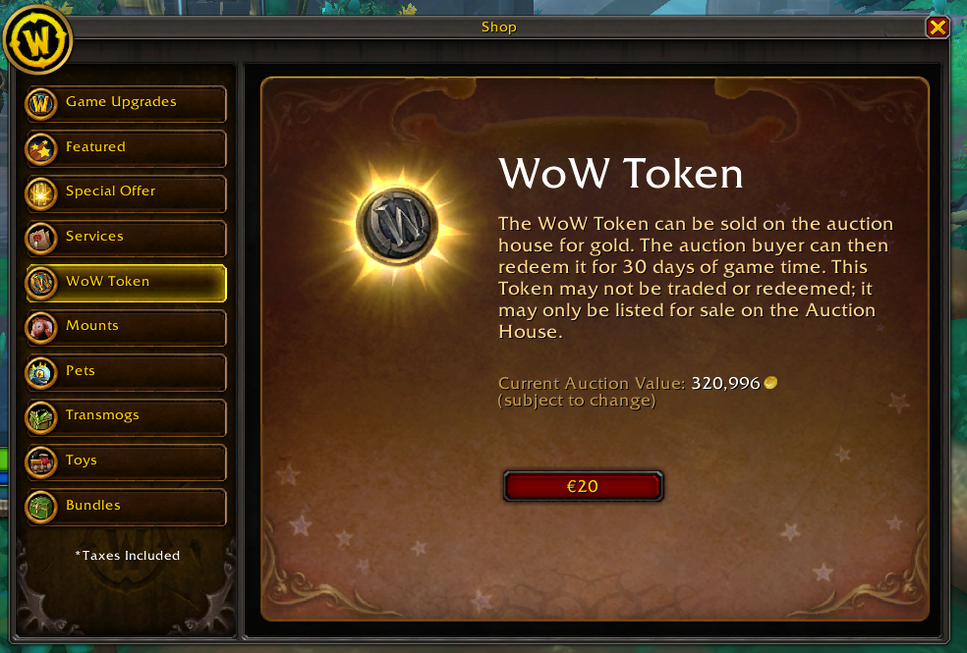

Figure 2 World of Warcraft in game store WoW token screenshot made on 22/11/2022[1]

Blizzard Entertainment, 2004, *World of Warcraft*, Irvine, Californië: Blizzard Entertainment

Crytek, 2019, *Hunt: Showdown*, Höfen, Tyrol, Crytek and Koch Media

miHoYo, 2021, *Genshin Impact*, Shanghai, China: miHoYo and Cognosphere

Law, Eric, 2022. “World of Warcraft: Sepulcher of the First Ones World First Race Cost Guilds $100,000” *GameRant Ogden, Utah*, March 29, 2022, Accessed November 22 2022. https://gamerant.com/world-of-warcraft-shadowlands-eternitys-end-sepulcher-of-the-first-ones-raid-world-first-race-cost/